Medication Polypharmacy among the Elderly.
Name.
Institution.
Date.

Medication Polypharmacy among the Elderly.

Definition of Polypharmacy.
Polypharmacy is one of the most sensitive and current issues in health care and many health care researchers and critics have sought to come up with a globally accepted definition of the practice.
Viktil et al., (2017), defines polypharmacy as the practice of administering more medications to clinically indicated patients in order to avert them from the un-necessary use of drugs.
General overview of the elderly people and medication-polypharmacy.
- According to Hohl (2016), the elderly people frequently take medications this group of people receives more than 50% of all prescription drugs.
- Medication polypharmacy is very critical among the elderly people who in most cases strive to counter diseases such as heart failure, hypertension and Diabetes Mellitus.
- Evidently, such diseases require more than one medication.
- The elderly people who are subjected to medication polypharmacy arguably take 6-8 medications on a daily basis.
- Medication polypharmacy among the elderly is affected or motivated by factors such as; access to quality health care, affordability of health services, and the availability of Over the Counter Drugs (Hohl, 2016).
- When subjected to medication polypharmacy, the elderly people can easily make mistakes or medication errors, and this is motivated by their age, irrationality, confusions, lack of guidance and their deteriorating cognitive capabilities.

Tips for countering and preventing medication errors among the elderly people undergoing medication polypharmacy.
- Review of patient's medication by the health workers in order to reduce polypharmacy as well as inappropriate prescription of drugs (Fulton & Riley, 2015).
- Health workers should rely on computerized systems and alert systems to reduce medication errors for the elderly people within the inpatient setting.
- Strictly rely on the recommendations provided by pharmacists to avoid inappropriate prescribing and adverse errors in medication.
- The elderly persons should be guided by a younger adult, a medical expert of a family member with medical knowledge to avoid errors.
- Provide community based educational sessions or forums to the adults in regard to medication and dosage (Steinman et al., 2015).
- Educate the elderly people about the adverse effects of making errors in medication polypharmacy.
Relevant information that should be shared with family and caregivers.
- Information about the patient's medical conditions or comorbidities.
- Information about all the relevant prognosis aspects.
- Information about the patient's treatment plans (Steinman et al., 2015).
- Information about the patient's medication, dosage as well as drug recommendations.
- Information about the patient's diet and recommendations (Fulton &Riley, 2015).
- Information about patient's reactions, allergies and side effects to drugs.
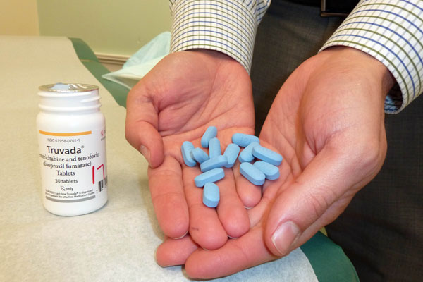Community Tools and local resources for reducing polypharmacy errors.
Community tools.
- START criteria
- STOPP Criteria.
- BEERS Criteria.
Local Resources.
- Community centers for the elderly and sick persons.
- Local doctors, pharmacists, and nurses.
- Local clinics, health centers, and pharmacies.

References.
Fulton, M. M., & Riley Allen, E. (2015). Polypharmacy in the elderly: a literature review. Journal of the American Association of Nurse Practitioners, 17(4), 123-132.
Hohl, C. M., Dankoff, J., Colacone, A., & Afilalo, M. (2016). Polypharmacy, adverse drug-related events, and potential adverse drug interactions in elderly patients presenting to an emergency department. Annals of emergency medicine, 38(6), 666-671.
Steinman, M. A., Seth Landefeld, C., Rosenthal, G. E., Berthenthal, D., Sen, S., & Kaboli, P. J. (2015). Polypharmacy and prescribing quality in older people. Journal of the American Geriatrics Society, 54(10), 1516-1523.
VikViktil, K. K., Blix, H. S., Moger, T. A., & Reikvam, A. (2017). Polypharmacy as commonly defined is an indicator of limited value in the assessment of drug‐related problems. British journal of clinical pharmacology, 63(2), 187-195.

